

Advertising Agency Business Plan
How to Use This Template
Edit this Google Doc version directly to fit your needs. This copy is yours.
This template is a simplified business plan outline. It’s a good way to get started, but as you know, you can’t just type in your details, print it, and turn it in to the bank. Every business is unique, and your business plan should reflect that. Use this template as the starting point to write your business plan and customize it to reflect your unique business.
What makes this template unique?
- Pro tips (noted in green) are based on our experience helping over a million business owners write their business plans. Consider these tips as you create your own plan.
- Writing your business plan is just one step in achieving your broader business goal. At the end of this template, you’ll find next steps to help you achieve your goal faster.
- Because you downloaded this business plan template—you get access to an exclusive offer for 50% off your first month of LivePlan, the #1 rated business plan builder, which can be found throughout this template.


Confidential

Your company name here
Your tagline here

Business Plan
Prepared [date]

Contact Information
Jane Smith
jane@yourcompany.com
111.222.333
yourcompany.com
1234 Main St.
Anywhere, OR 12345
Table of contents
Executive Summary 1
Mission 1
Company Summary 3
Company Ownership 3
Start-up Summary 3
Services 7
Market Analysis Summary 8
Market Segmentation 8
Service Business Analysis 9
Strategy and Implementation Summary 10
Marketing Strategy 10
Sales Strategy 10
Sales Forecast 10
Competitive Edge 12
Management Summary 13
Financial Plan 14
Break-even Analysis 14
Projected Profit and Loss 15
Projected Cash Flow 17
Projected Balance Sheet 19
Business Ratios 20
Appendix 23
Table: Sales Forecast 23
Table: Personnel 24
Table: General Assumptions 24
Table: Cash Flow 26
Table: Balance Sheet 29

Executive Summary
⭐️ Pro tip: We typically recommend you revisit this section after you’ve finished the rest of your business plan so that you can easily summarize what you’ve already written.

Promerit Advertising will offer marketing services to companies that are looking to employ email marketing techniques as the cornerstone of their marketing program. It is estimated that in Year 1, over 250 billion emails will travel across cyberspace. Email marketing is quickly becoming a cost-effective method to reach a target audience. According to Jupiter Communication research, email ad-response rates currently averages between five to 15 percent. At the same time, the report noted that only 15 percent of Web users read all email messages in their entirety.

The potential is there but so is the risk that the target customer will completely reject the advertising. Email marketing is a science. There are effective strategies that will assure that the company will reach the greatest number of potential customers.

Promerit Advertising specializes in successful email marketing campaigns. Its owners, Robert Humphrey and Cheryl Littlejohn have over eight years of experience in email marketing campaigns between them. Robert was project leader for the successful Buy.com and Verizon email marketing campaign. Cheryl was technical lead of 800.com's successful email campaign before joining Robert as technical lead of the Verizon email campaign.

Promerit Advertising will design, build, test and deploy the email campaign. It will also report the progress of the campaign in real-time to provide our customers maximum flexibility. At the end of the campaign, Promerit will analyze its success in order to improve the company's future campaigns.

Mission
Promerit Advertising will offer its customers the best methods and tools in planning and implementing a successful email campaign. Our campaigns will cut through the mumbo jumbo of mass marketing, increase sales, and enhance customer satisfaction with the company. Promerit Advertising email campaigns will grab readers immediately and drive home the right message to the right audience. We will exceed our customers' expectations for campaign returns.
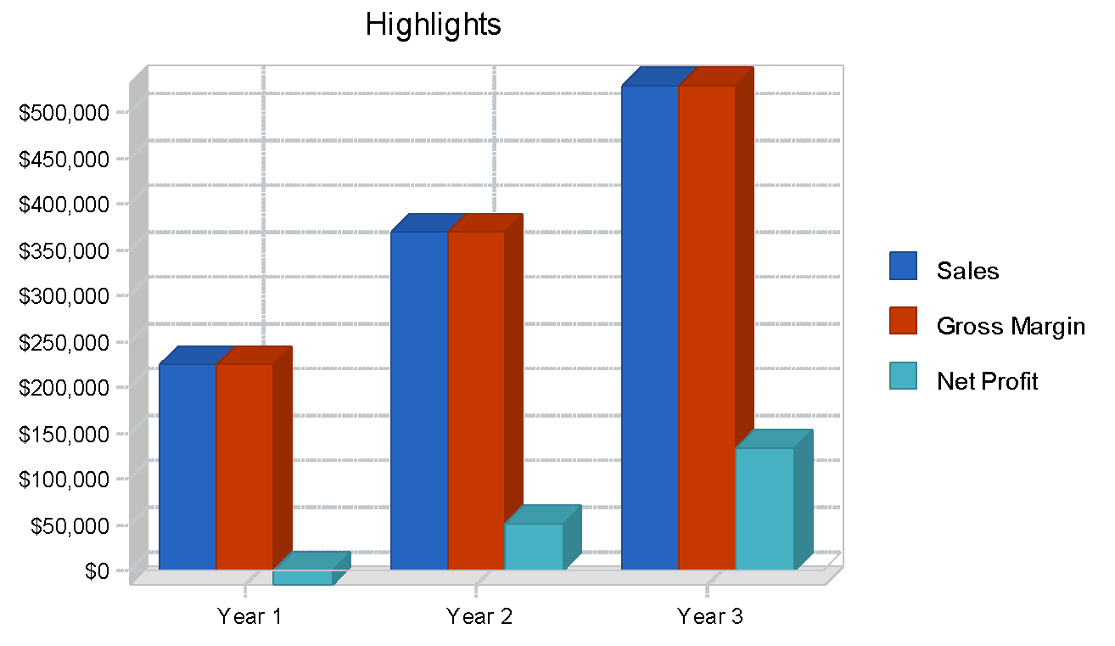



Company Summary
⭐ Pro tip: Skip fine-tuning and testing prompts with the AI-powered LivePlan Assistant. We’ve done all the back-end work so you can generate personalized plan sections that you can actually use.

Promerit Advertising will design, build, test and deploy the email campaign. It will also report the progress of the campaign in real-time to provide our customers maximum flexibility. At the end of the campaign, Promerit will analyze its success in order to improve the company's future campaigns.

Company Ownership
Robert Humphrey and Cheryl Littlejohn are the owners of Promerit Advertising.

Start-up Summary
Robert Humphrey and Cheryl Littlejohn will invest equally in the company. They will also secure a long-term business loan. The following table and chart show projected initial start-up costs of Promerit Advertising.

Start-up Funding
Start-up Expenses to Fund | $34,500
Start-up Assets to Fund | $165,500
Total Funding Required | $200,000
Assets
Non-cash Assets from Start-up | $10,000
Cash Requirements from Start-up | $155,500
Additional Cash Raised | $0
Cash Balance on Starting Date | $155,500
Total Assets | $165,500
Liabilities and Capital
Liabilities
Current Borrowing | $0
Long-term Liabilities | $100,000
Accounts Payable (Outstanding Bills) | $0
Other Current Liabilities (interest-free) | $0
Total Liabilities | $100,000
Capital
Planned Investment
Robert Humphrey | $50,000
Cheryl Littlejohn | $50,000
Other | $0
Additional Investment Requirement | $0
Total Planned Investment | $100,000
Loss at Start-up (Start-up Expenses) | -$34,500
Total Capital | $65,500
Total Capital and Liabilities | $165,500
Total Funding | $200,000
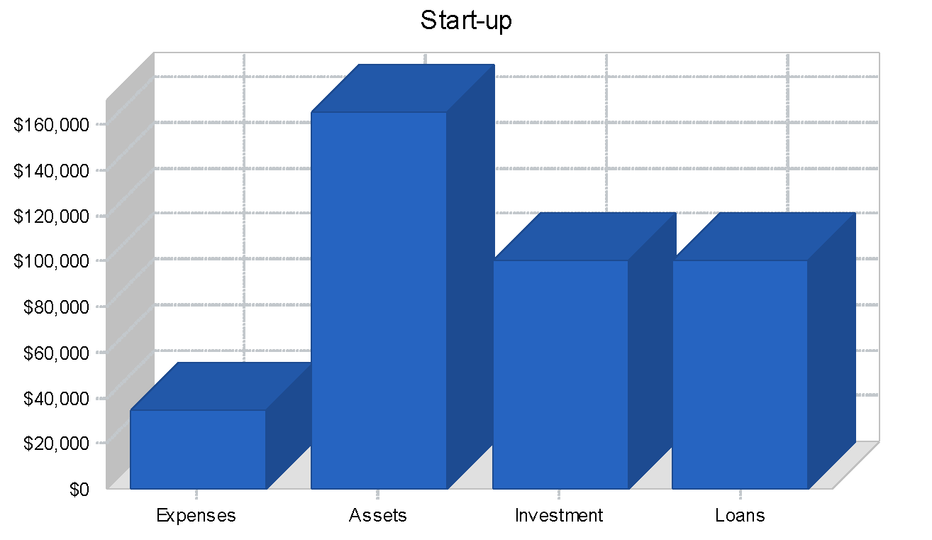

Start-up
Requirements
Start-up Expenses
Legal | $1,000
Stationery etc. | $1,000
Brochures | $1,000
Advertising | $20,000
Expensed Computer Equipment/Software | $10,000
Insurance | $0
Rent | $1,500
Research and Development | $0
Other | $0
Total Start-up Expenses | $34,500
Start-up Assets
Cash Required | $155,500
Other Current Assets | $10,000
Long-term Assets | $0
Total Assets | $165,500
Total Requirements | $200,000

Services
The services offered by Promerit Advertising cover an email marketing project in its entirety, from original concept to post-campaign evaluation. The service includes the following:

- Design the campaign
- Personalization and targeting
- Email list management
- Building deployment system
- Testing the plan
- Implementing the campaign
- Tracking the campaign's progress in real-time
- Instant measurability for ROI analysis
- Post-campaign analysis



Market Analysis Summary
⭐Pro tip: Enhance your competitive analysis by using LivePlan's industry benchmarks to identify where your business can outperform market averages.

It was recently reported in an eMarketeer online advertising report that online promotions are very powerful with offline companies, as well as online companies. Though offline companies are offering promotions that necessitate the customer going to one of the company's stores, consumers feel positive about the online promotions. This opens up a new avenue for these companies to target customer groups that use computers at work and at home.
Consumers said they cared mostly about return policies, customer service, and product selection. A very impressive 94 percent of surveyed users reported they have shopped online before. About 76 percent of those surveyed said promotions were a positive influence on their buying behavior. Some 50 percent said online coupons were especially persuasive while 70 percent found offline coupons equally attractive.
An email campaign can be used to reach target customers no matter how small a company's Internet presence is, as long as the customer wants the product.

Market Segmentation
There are two distinct customer groups that Promerit Advertising is focused on:
- Online companies with e-commerce
- Offline companies

Market Analysis
 |  | Year 1 | Year 2 | Year 3 | Year 4 | Year 5
Potential Customers | Growth |  |  |  |  |  | CAGR
Online Companies | 30% | $630,900 | $820,170 | $1,066,221 | $1,386,087 | $1,801,913 | 30.00%
Offline Companies | 0% | $1,500,700 | $1,500,700 | $1,500,700 | $1,500,700 | $1,500,700 | 0.00%
Other | 0% | $0 | $0 | $0 | $0 | $0 | 0.00%
Total | 11.57% | $2,131,600 | $2,320,870 | $2,566,921 | 2,886,787 | 3,302,613 | 11.57%

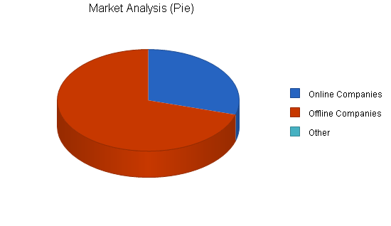

Service Business Analysis
By any measure, the Internet is one of the fastest-growing commercial phenomena ever witnessed by society. Host computers, or servers, have exploded from 3.2 million in 1994 to roughly 79.2 million as of July 2001. During the same time period, the number of websites roared to more than 6 million from only 3,000.
A key factor in the recent growth of the Internet is the popularity of the sub-$1,000 PC. Rapidly falling component prices have allowed PC manufacturers to pass cost savings on to their customers, resulting in a more attractively priced product. Computers sold at or below the $1,000 level have appealed to first-time PC users and lower income families. Because of the more affordable prices, PC penetration in the United States is now approximately 50%, according to Dataquest, a market research firm based in San Jose, California.
The United States accounts for more than half of the world's total Internet users. When consumers today are asked why they purchased a personal computer, the most common answer is to connect to the Internet to get their email.

Strategy and Implementation Summary
⭐️ Pro tip: Using the power of AI, LivePlan Assistant’s Rewrite feature will instantly help add additional details to each of these sections when prompted.

Promerit Advertising's strategy is to utilize the extensive network of contacts both Robert and Cheryl have with companies already sold on the value of email marketing. In addition, Promerit will use its internal expertise to launch an email marketing campaign directed at a select group of its target customers.

Marketing Strategy
With over two million potential customers, Promerit Advertising will focus an email campaign on a select group of 50,000 businesses each fiscal quarter. We estimate a five percent response rate to the campaign which will generate 1,250 leads. These leads will then be used to generate business contacts. Over the year, we will generate 5,000 leads.

Sales Strategy
Promerit Advertising's sales strategy is simple. We will use the email marketing campaign directed at our customer base as a model of what we can accomplish for them. We anticipate that online companies will be most accessible to our services. We will be successful with offline companies overtime, but initially sales will be weak with this group.

Sales Forecast
The following is the sales forecast for three years. We have no cost of sales, as all of our deliverables are electronic, and our labor costs are included in the Personnel table.

Sales Forecast
 | Year 1 | Year 2 | Year 3
Sales
Online Companies | $178,830 | $270,000 | $360,000
Offline Companies | $47,000 | $100,000 | $170,000
Total Sales | $225,830 | $370,000 | $530,000
Direct Cost of Sales | Year 1 | Year 2 | Year 3
Online Companies | $0 | $0 | $0
Offline Companies | $0 | $0 | $0
Subtotal Direct Cost of Sales | $0 | $0 | $0

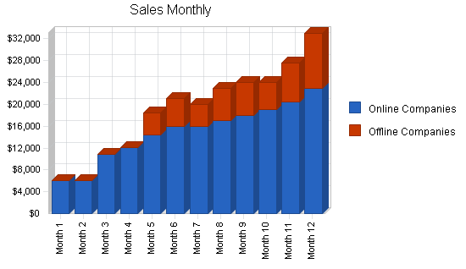
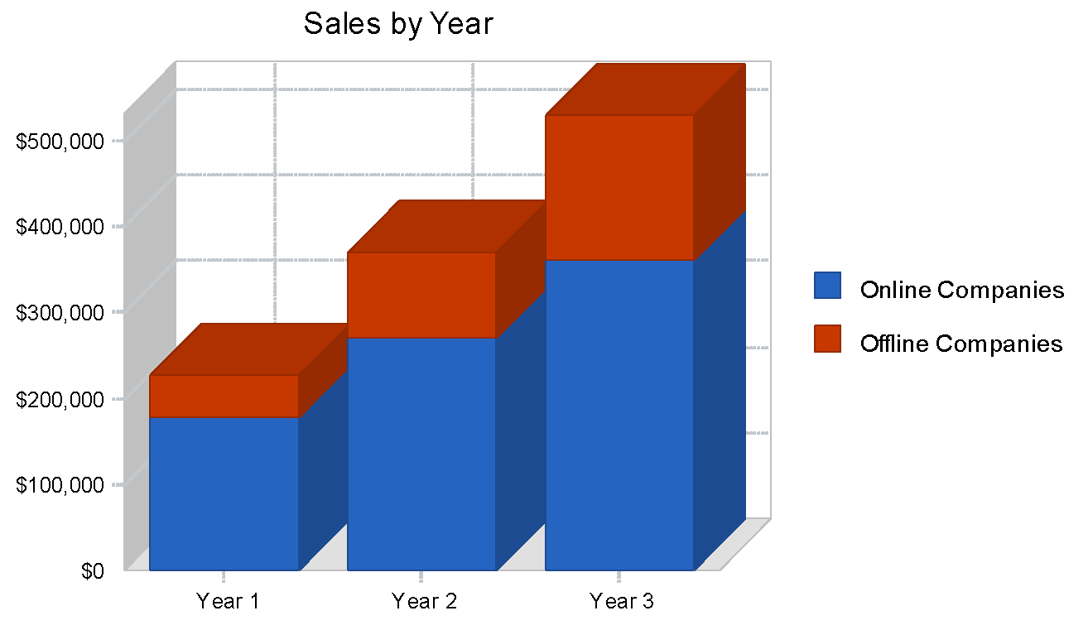

Competitive Edge
Robert Humphrey has five years of experience in email marketing campaigns and ten years of experience in direct marketing. He is a graduate of Ohio State University with a BA in marketing. Robert worked with several advertising companies before arriving at Kemp and Johnson Advertising in 1997. With Kemp and Johnson, Robert created and grew the Internet marketing group. Robert was project leader for the successful Buy.com and Verison email marketing campaign.

Cheryl Littlejohn graduated with a BS in computer science from UCLA in 1996. She immediately went to work for the Internet start-up Temple Communication as an IT administrator. She left in 1998 to join the start-up 800.com as the technical lead of its email campaign. In 2000, she joined Richard's Internet group at Kemp and Johnson as technical lead of the Verison email marketing campaign.

Email marketing is an emerging marketing tool with few industry experts. Robert and Cheryl's accomplishments over the past three years has been singled out by the industry as models for successful email marketing campaigns.

Management Summary
Robert Humphrey will be responsible for tactical elements of the marketing campaign and Cheryl Littlejohn will manage the technical aspects of the campaign.

In addition to Robert and Cheryl, there will be three other staff members:
- Secretary/Receptionist
- Accountant
- Salesperson

Personnel Plan
 | Year 1 | Year 2 | Year 3
Robert Humphrey | $32,000 | $40,000 | $45,000
Cheryl Littlejohn | $32,000 | $40,000 | $45,000
Secretary/Receptionist | $20,000 | $25,000 | $28,000
Salesperson | $38,000 | $50,000 | $55,000
Bookkeeper | $20,000 | $26,000 | $29,000
Other | $0 | $0 | $0
Total People | 5 | 5 | 0
Total Payroll | $142,000 | $181,000 | $202,000

Financial Plan
⭐ Pro tip: Not sure how you’ll make money or what your expenses might be? LivePlan Assistant’s Suggested Forecast Categories will generate suggestions for revenue streams, direct costs, personnel, and expenses specific to your business.

⭐ Pro tip: Leverage LivePlan's Monthly Review to identify seasonal patterns in your business. Understanding these cycles helps you better manage cash flow and inventory throughout the year.

The financial plan is presented in the following topics.

Break-even Analysis
The monthly sales break-even point is is shown in the table and chart below.

Break-even Analysis
Monthly Revenue Break-even | $19,308
Assumptions:
Average Percent Variable Cost | 0%
Estimated Monthly Fixed Cost | $19,308
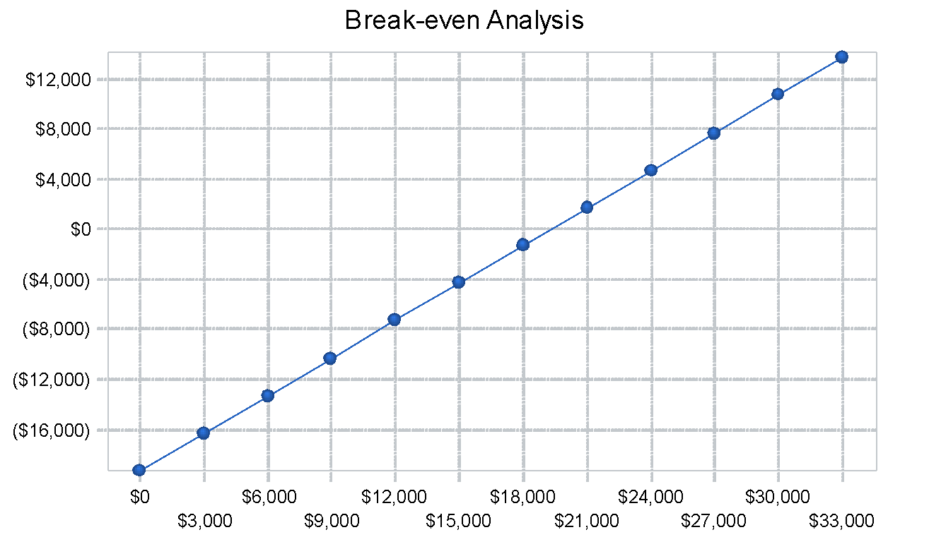

Projected Profit and Loss
The following table and charts outline the projected profit and loss for three years. We estimate that the agency will not be profitable until the second year of operation. Promerit Advertising will then grow by about 9% for the second and third year.
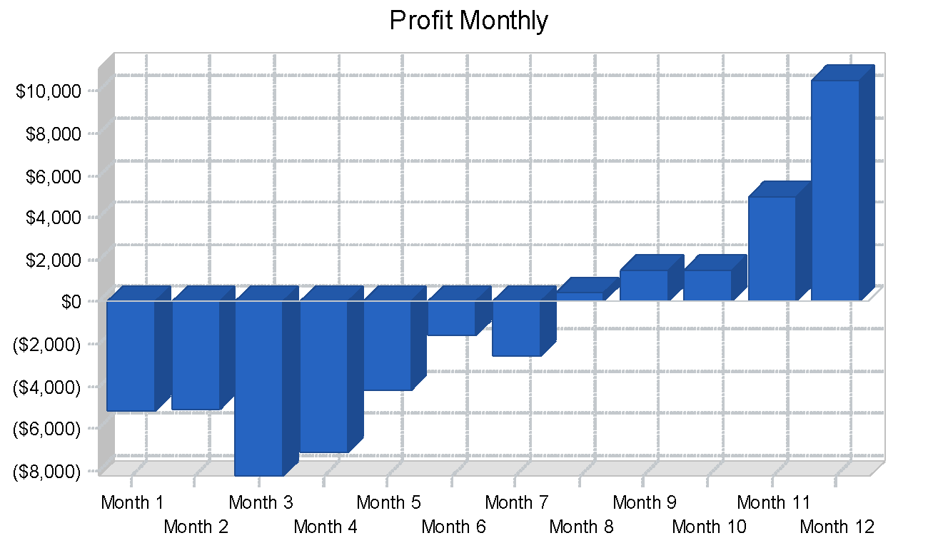
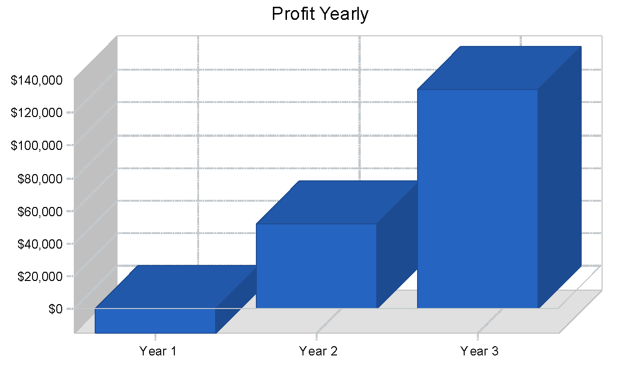
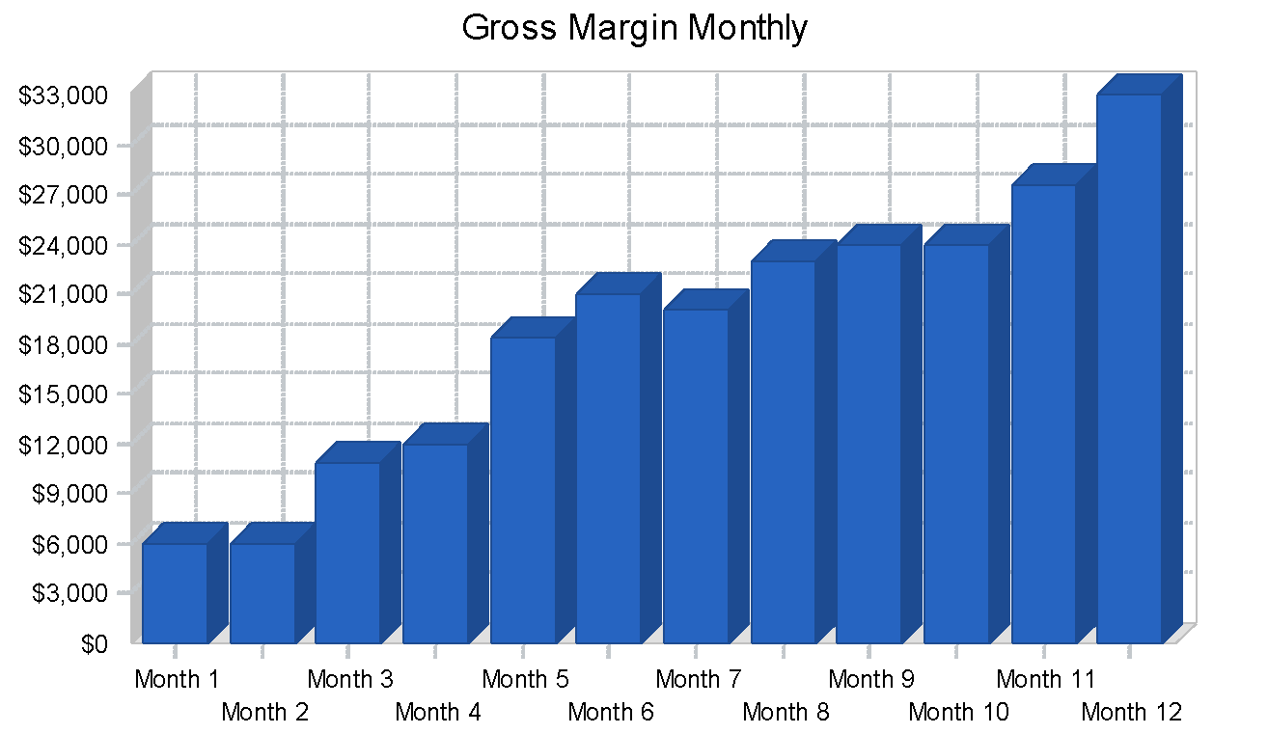
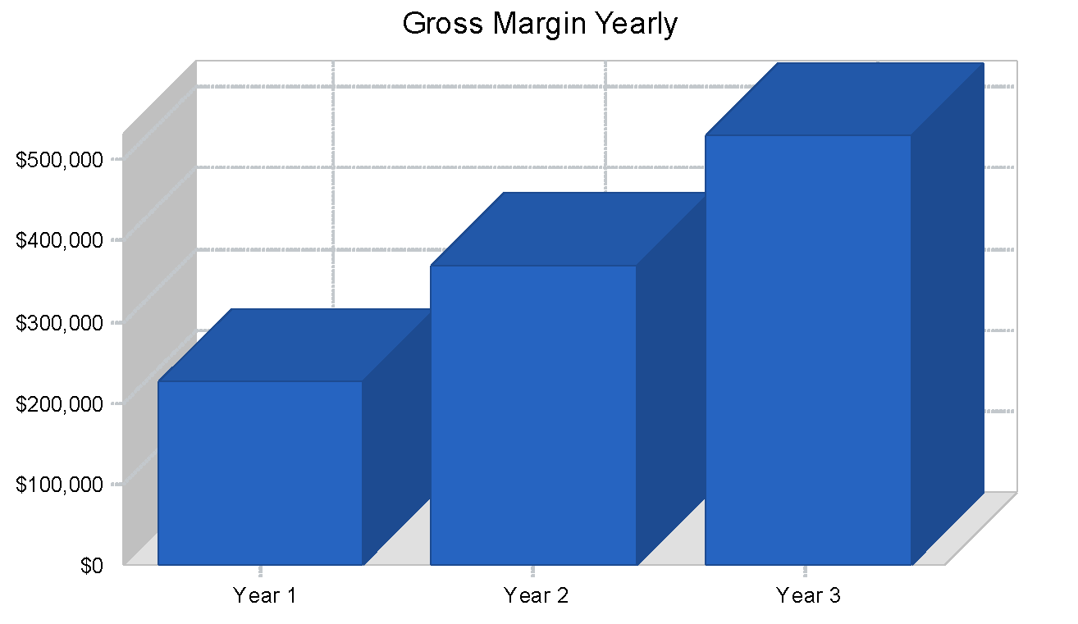
Pro Forma Profit and Loss
 | Year 1 | Year 2 | Year 3
Sales | $225,830 | $370,000 | $530,000
Direct Cost of Sales | $0 | $0 | $0
Other Production Expenses | $0 | $0 | $0
Total Cost of Sales | $0 | $0 | $0
Gross Margin | $225,830 | $370,000 | $530,000
Gross Margin % | 100.00% | 100.00% | 100.00%
Expenses
Payroll | $142,000 | $181,000 | $202,000
Sales and Marketing and Other Expenses | $48,000 | $60,000 | $80,000
Depreciation | $0 | $0 | $0
Leased Equipment | $0 | $0 | $0
Utilities | $2,400 | $2,400 | $2,400
Insurance | $0 | $0 | $0
Rent | $18,000 | $18,000 | $18,000
Payroll Taxes | $21,300 | $27,150 | $30,300
Other | $0 | $0 | $0
Total Operating Expenses | $231,700 | $288,550 | $332,700
Profit Before Interest and Taxes | -$5,870 | $81,450 | $197,300
EBITDA | -$5,870 | $81,450 | $197,300
Interest Expense | $8,916 | $6,999 | $4,999
Taxes Incurred | $0 | $22,335 | $57,690
Net Profit | -$14,786 | $52,115 | $134,611
Net Profit/Sales | -6.55% | 14.09% | 25.40%

Projected Cash Flow
The following table and chart highlight the projected cash flow for three years.
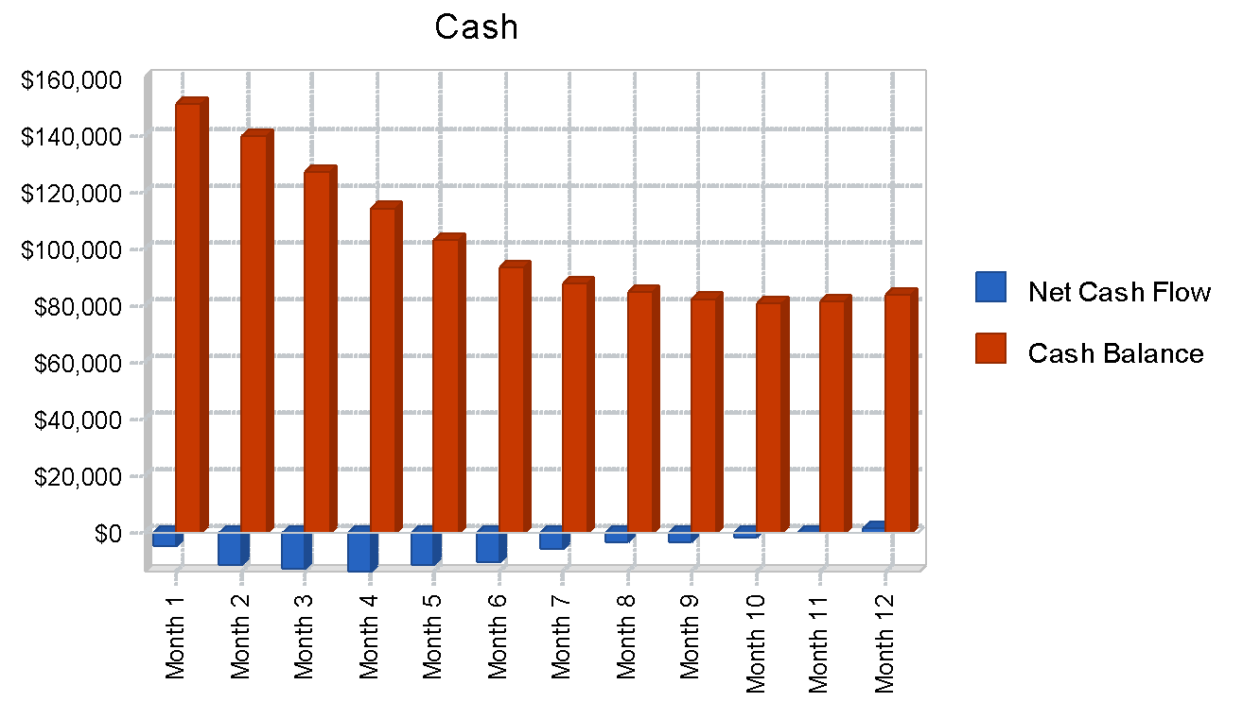
Pro Forma Cash Flow
 | Year 1 | Year 2 | Year 3
Cash Received
Cash from Operations
Cash Sales | $56,458 | $92,500 | $132,500
Cash from Receivables | $124,685 | $248,971 | $365,839
Subtotal Cash from Operations | $181,143 | $341,471 | $498,339
Additional Cash Received
Sales Tax, VAT, HST/GST Received | $0 | $0 | $0
New Current Borrowing | $0 | $0 | $0
New Other Liabilities (interest-free) | $0 | $0 | $0
New Long-term Liabilities | $0 | $0 | $0
Sales of Other Current Assets | $0 | $0 | $0
Sales of Long-term Assets | $0 | $0 | $0
New Investment Received | $0 | $0 | $0
Subtotal Cash Received | $181,143 | $341,471 | $498,339
Expenditures | Year 1 | Year 2 | Year 3
Expenditures from Operations
Cash Spending | $142,000 | $181,000 | $202,000
Bill Payments | $90,432 | $133,818 | $188,745
Subtotal Spent on Operations | $232,432 | $314,818 | $390,745
Additional Cash Spent
Sales Tax, VAT, HST/GST Paid Out | $0 | $0 | $0
Principal Repayment of Current Borrowing | $0 | $0 | $0
Other Liabilities Principal Repayment | $0 | $0 | $0
Long-term Liabilities Principal Repayment | $20,004 | $20,004 | $20,004
Purchase Other Current Assets | $0 | $0 | $0
Purchase Long-term Assets | $0 | $0 | $0
Dividends | $0 | $0 | $0
Subtotal Cash Spent | $252,436 | $334,822 | $410,749
Net Cash Flow | -$71,294 | $6,649 | $87,590
Cash Balance | $84,206 | $90,856 | $178,446

Projected Balance Sheet
The table shows projected balance sheet for three years.

Pro Forma Balance Sheet
 | Year 1 | Year 2 | Year 3
Assets
Current Assets
Cash | $84,206 | $90,856 | $178,446
Accounts Receivable | $44,688 | $73,216 | $104,877
Other Current Assets | $10,000 | $10,000 | $10,000
Total Current Assets | $138,894 | $174,072 | $293,323
Long-term Assets
Long-term Assets | $0 | $0 | $0
Accumulated Depreciation | $0 | $0 | $0
Total Long-term Assets | $0 | $0 | $0
Total Assets | $138,894 | $174,072 | $293,323
Liabilities and Capital | Year 1 | Year 2 | Year 3
Current Liabilities
Accounts Payable | $8,184 | $11,251 | $15,895
Current Borrowing | $0 | $0 | $0
Other Current Liabilities | $0 | $0 | $0
Subtotal Current Liabilities | $8,184 | $11,251 | $15,895
Long-term Liabilities | $79,996 | $59,992 | $39,988
Total Liabilities | $88,180 | $71,243 | $55,883
Paid-in Capital | $100,000 | $100,000 | $100,000
Retained Earnings | -$34,500 | -$49,286 | $2,829
Earnings | -$14,786 | $52,115 | $134,611
Total Capital | $50,714 | $102,829 | $237,440
Total Liabilities and Capital | $138,894 | $174,072 | $293,323
Net Worth | $50,714 | $102,829 | $237,440

Business Ratios
Business ratios for the years of this plan are shown below. Industry profile ratios based on the Standard Industrial Classification (SIC) code 7311, Advertising Agencies, are shown for comparison.

Ratio Analysis
 | Year 1 | Year 2 | Year 3 | Industry Profile
Sales Growth | n.a. | 63.84% | 43.24% | 8.50%
Percent of Total Assets
Accounts Receivable | 32.17% | 42.06% | 35.75% | 36.20%
Other Current Assets | 7.20% | 5.74% | 3.41% | 42.20%
Total Current Assets | 100.00% | 100.00% | 100.00% | 80.80%
Long-term Assets | 0.00% | 0.00% | 0.00% | 19.20%
Total Assets | 100.00% | 100.00% | 100.00% | 100.00%
Current Liabilities | 5.89% | 6.46% | 5.42% | 42.90%
Long-term Liabilities | 57.60% | 34.46% | 13.63% | 13.00%
Total Liabilities | 63.49% | 40.93% | 19.05% | 55.90%
Net Worth | 36.51% | 59.07% | 80.95% | 44.10%
Percent of Sales
Sales | 100.00% | 100.00% | 100.00% | 100.00%
Gross Margin | 100.00% | 100.00% | 100.00% | 0.00%
Selling, General & Administrative Expenses | 106.55% | 85.91% | 74.60% | 81.60%
Advertising Expenses | 21.25% | 16.22% | 15.09% | 3.50%
Profit Before Interest and Taxes | -2.60% | 22.01% | 37.23% | 2.50%
Main Ratios
Current | $17 | $15 | $18 | $2
Quick | $17 | $15 | $18 | $1
Total Debt to Total Assets | 63.49% | 40.93% | 19.05% | 55.90%
Pre-tax Return on Net Worth | -29.16% | 72.40% | 80.99% | 5.70%
Pre-tax Return on Assets | -10.65% | 42.77% | 65.56% | 12.80%
Additional Ratios | Year 1 | Year 2 | Year 3
Net Profit Margin | -6.55% | 14.09% | 25.40% | n.a
Return on Equity | -29.16% | 50.68% | 56.69% | n.a
Activity Ratios
Accounts Receivable Turnover | $4 | 3.79 | 3.79 | n.a
Collection Days | $56 | $78 | $82 | n.a
Accounts Payable Turnover | $12 | $12 | $12 | n.a
Payment Days | 27 | 26 | 26 | n.a
Total Asset Turnover | 1.63 | 2.13 | 1.81 | n.a
Debt Ratios
Debt to Net Worth | 1.74 | 0.69 | 0.24 | n.a
Current Liab. to Liab. | 0.09 | 0.16 | 0.28 | n.a
Liquidity Ratios
Net Working Capital | $130,710 | $162,821 | $277,428 | n.a
Interest Coverage | -0.66 | 11.64 | 39.47 | n.a
Additional Ratios
Assets to Sales | 0.62 | 0.47 | 0.55 | n.a
Current Debt/Total Assets | 6% | 6% | 5% | n.a
Acid Test | 11.51 | 8.96 | 11.86 | n.a
Sales/Net Worth | 4.45 | 3.6 | 2.23 | n.a
Dividend Payout | 0 | 0 | 0 | n.a



Appendix

Table: Sales Forecast
Sales Forecast
 |  | Month 1 | Month 2 | Month 3 | Month 4 | Month 5 | Month 6 | Month 7 | Month 8 | Month 9 | Month 10 | Month 11 | Month 12
Sales
Online Companies | 0% | $6,000 | $6,000 | $10,900 | $12,030 | $14,400 | $16,000 | $16,000 | $17,000 | $18,000 | $19,000 | $20,500 | $23,000
Offline Companies | 0% | $0 | $0 | $0 | $0 | $4,000 | $5,000 | $4,000 | $6,000 | $6,000 | $5,000 | $7,000 | $10,000
Total Sales |  | $6,000 | $6,000 | $10,900 | $12,030 | $18,400 | $21,000 | $20,000 | $23,000 | $24,000 | $24,000 | $27,500 | $33,000
Direct Cost of Sales |  | Month 1 | Month 2 | Month 3 | Month 4 | Month 5 | Month 6 | Month 7 | Month 8 | Month 9 | Month 10 | Month 11 | Month 12
Online Companies |  | $0 | $0 | $0 | $0 | $0 | $0 | $0 | $0 | $0 | $0 | $0 | $0
Offline Companies |  | $0 | $0 | $0 | $0 | $0 | $0 | $0 | $0 | $0 | $0 | $0 | $0
Subtotal Direct Cost of Sales |  | $0 | $0 | $0 | $0 | $0 | $0 | $0 | $0 | $0 | $0 | $0 | $0

Table: Personnel
Personnel Plan
 |  | Month 1 | Month 2 | Month 3 | Month 4 | Month 5 | Month 6 | Month 7 | Month 8 | Month 9 | Month 10 | Month 11 | Month 12
Robert Humphrey | 0% | $2,000 | $2,000 | $2,000 | $2,000 | $3,000 | $3,000 | $3,000 | $3,000 | $3,000 | $3,000 | $3,000 | $3,000
Cheryl Littlejohn | 0% | $2,000 | $2,000 | $2,000 | $2,000 | $3,000 | $3,000 | $3,000 | $3,000 | $3,000 | $3,000 | $3,000 | $3,000
Secretary/Receptionist | 0% | $0 | $0 | $2,000 | $2,000 | $2,000 | $2,000 | $2,000 | $2,000 | $2,000 | $2,000 | $2,000 | $2,000
Salesperson | 0% | $0 | $0 | $3,000 | $3,000 | $4,000 | $4,000 | $4,000 | $4,000 | $4,000 | $4,000 | $4,000 | $4,000
Bookkeeper | 0% | $0 | $0 | $2,000 | 2,000 | 2,000 | $2,000 | $2,000 | $2,000 | $2,000 | $2,000 | $2,000 | $2,000
Other | 0% | $0 | $0 | $0 | $0 | $0 | $0 | $0 | $0 | $0 | $0 | $0 | $0
Total People |  | $5 | $5 | $5 | $5 | $5 | $5 | $5 | $5 | $5 | $5 | $5 | $5
Total Payroll |  | $4,000 | $4,000 | $11,000 | $11,000 | $14,000 | $14,000 | $14,000 | $14,000 | $14,000 | $14,000 | $14,000 | $14,000

Table: General Assumptions
General Assumptions
 | Month 1 | Month 2 | Month 3 | Month 4 | Month 5 | Month 6 | Month 7 | Month 8 | Month 9 | Month 10 | Month 11 | Month 12
Plan Month | $1 | $2 | $3 | $4 | $5 | $6 | $7 | $8 | $9 | $10 | $11 | $12
Current Interest Rate | 10.00% | 10.00% | 10.00% | 10.00% | 10.00% | 10.00% | 10.00% | 10.00% | 10.00% | 10.00% | 10.00% | 10.00%
Long-term Interest Rate | 10.00% | 10.00% | 10.00% | 10.00% | 10.00% | 10.00% | 10.00% | 10.00% | 10.00% | 10.00% | 10.00% | 10.00%
Tax Rate | 30.00% | 30.00% | 30.00% | 30.00% | 30.00% | 30.00% | 30.00% | 30.00% | 30.00% | 30.00% | 30.00% | 30.00%
Other | $0 | $0 | $0 | 0 | 0 | $0 | $0 | $0 | $0 | $0 | $0 | $0

Table: Profit and Loss
Pro Forma Profit and Loss
 |  | Month 1 | Month 2 | Month 3 | Month 4 | Month 5 | Month 6 | Month 7 | Month 8 | Month 9 | Month 10 | Month 11 | Month 12
Sales |  | $6,000 | $6,000 | $10,900 | $12,030 | $18,400 | $21,000 | $20,000 | $23,000 | $24,000 | $24,000 | $27,500 | $33,000
Direct Cost of Sales |  | $0 | $0 | $0 | $0 | $0 | $0 | $0 | $0 | $0 | $0 | $0 | $0
Other Production Expenses |  | $0 | $0 | $0 | $0 | $0 | $0 | $0 | $0 | $0 | $0 | $0 | $0
Total Cost of Sales |  | $0 | $0 | $0 | $0 | $0 | $0 | $0 | $0 | $0 | $0 | $0 | $0
Gross Margin |  | $6,000 | $6,000 | $10,900 | $12,030 | $18,400 | $21,000 | $20,000 | $23,000 | $24,000 | $24,000 | $27,500 | $33,000
Gross Margin % |  | 100.00% | 100.00% | 100.00% | 100.00% | 100.00% | 100.00% | 100.00% | 100.00% | 100.00% | 100.00% | 100.00% | 100.00%
Expenses
Payroll |  | $4,000 | $4,000 | $11,000 | $11,000 | $14,000 | $14,000 | $14,000 | $14,000 | $14,000 | $14,000 | $14,000 | $14,000
Sales and Marketing and Other Expenses |  | $4,000 | $4,000 | $4,000 | $4,000 | $4,000 | $4,000 | $4,000 | $4,000 | $4,000 | $4,000 | $4,000 | $4,000
Depreciation |  | $0 | $0 | $0 | $0 | $0 | $0 | $0 | $0 | $0 | $0 | $0 | $0
Leased Equipment |  | $0 | $0 | $0 | $0 | $0 | $0 | $0 | $0 | $0 | $0 | $0 | $0
Utilities |  | $200 | $200 | $200 | $200 | $200 | $200 | $200 | $200 | $200 | $200 | $200 | $200
Insurance |  | $0 | $0 | $0 | $0 | $0 | $0 | $0 | $0 | $0 | $0 | $0 | $0
Rent |  | $1,500 | $1,500 | $1,500 | $1,500 | $1,500 | $1,500 | $1,500 | $1,500 | $1,500 | $1,500 | $1,500 | $1,500
Payroll Taxes | 15% | $600 | $600 | $1,650 | $1,650 | $2,100 | $2,100 | $2,100 | $2,100 | $2,100 | $2,100 | $2,100 | $2,100
Other |  | $0 | $0 | $0 | $0 | $0 | $0 | $0 | $0 | $0 | $0 | $0 | $0
Total Operating Expenses |  | $10,300 | $10,300 | $18,350 | $18,350 | $21,800 | $21,800 | $21,800 | $21,800 | $21,800 | $21,800 | $21,800 | $21,800
Profit Before Interest and Taxes |  | -$4,300 | -$4,300 | -$7,450 | -$6,320 | -$3,400 | -$800 | -$1,800 | $1,200 | $2,200 | $2,200 | $5,700 | $11,200
EBITDA |  | -$4,300 | -$4,300 | -$7,450 | -$6,320 | -$3,400 | -$800 | -$1,800 | $1,200 | $2,200 | $2,200 | $5,700 | $11,200
Interest Expense |  | $819 | $806 | $792 | $778 | $764 | $750 | $736 | $722 | $708 | $694 | $681 | $667
Taxes Incurred |  | $0 | $0 | $0 | $0 | $0 | $0 | $0 | $0 | $0 | $0 | $0 | $0
Net Profit |  | -$5,119 | -$5,106 | -$8,242 | -$7,098 | -$4,164 | -$1,550 | -$2,536 | $478 | $1,492 | $1,506 | $5,019 | $10,533
Net Profit/Sales |  | -85.32% | -85.09% | -75.61% | -59.00% | -22.63% | -7.38% | -12.68% | 2.08% | 6.22% | 6.27% | 18.25% | 31.92%

Table: Cash Flow
Pro Forma Cash Flow
 | Month 1 | Month 2 | Month 3 | Month 4 | Month 5 | Month 6 | Month 7 | Month 8 | Month 9 | Month 10 | Month 11 | Month 12
Cash Received
Cash from Operations
Cash Sales | $1,500 | $1,500 | $2,725 | $3,008 | $4,600 | $5,250 | $5,000 | $5,750 | $6,000 | $6,000 | $6,875 | $8,250
Cash from Receivables | $0 | $150 | $4,500 | 4,623 | 8,203 | $9,182 | $13,865 | $15,725 | $15,075 | $17,275 | $18,000 | $18,088
Subtotal Cash from Operations | $1,500 | $1,650 | $7,225 | $7,630 | $12,803 | $14,432 | $18,865 | $21,475 | $21,075 | $23,275 | $24,875 | $26,338
Additional Cash Received
Sales Tax, VAT, HST/GST Received | $0 | $0 | $0 | $0 | $0 | $0 | $0 | $0 | $0 | $0 | $0 | $0
New Current Borrowing | $0 | $0 | $0 | $0 | $0 | $0 | $0 | $0 | $0 | $0 | $0 | $0
New Other Liabilities (interest-free) | $0 | $0 | $0 | $0 | $0 | $0 | $0 | $0 | $0 | $0 | $0 | $0
New Long-term Liabilities | $0 | $0 | $0 | $0 | $0 | $0 | $0 | $0 | $0 | $0 | $0 | $0
Sales of Other Current Assets | $0 | $0 | $0 | $0 | $0 | $0 | $0 | $0 | $0 | $0 | $0 | $0
Sales of Long-term Assets | $0 | $0 | $0 | $0 | $0 | $0 | $0 | $0 | $0 | $0 | $0 | $0
New Investment Received | $0 | $0 | $0 | $0 | $0 | $0 | $0 | $0 | $0 | $0 | $0 | $0
Subtotal Cash Received | $1,500 | $1,650 | $7,225 | $7,630 | $12,803 | $14,432 | $18,865 | $21,475 | $21,075 | $23,275 | $24,875 | $26,338
Expenditures | Month 1 | Month 2 | Month 3 | Month 4 | Month 5 | Month 6 | Month 7 | Month 8 | Month 9 | Month 10 | Month 11 | Month 12
Expenditures from Operations
Cash Spending | $4,000 | $4,000 | $11,000 | $11,000 | $14,000 | $14,000 | $14,000 | $14,000 | $14,000 | $14,000 | $14,000 | $14,000
Bill Payments | $237 | $7,119 | $7,140 | $8,141 | $8,142 | $8,563 | $8,550 | $8,536 | $8,522 | $8,508 | $8,494 | $8,480
Subtotal Spent on Operations | $4,237 | $11,119 | $18,140 | $19,141 | $22,142 | $22,563 | $22,550 | $22,536 | $22,522 | $22,508 | $22,494 | $22,480
Additional Cash Spent
Sales Tax, VAT, HST/GST Paid Out | $0 | $0 | $0 | $0 | $0 | $0 | $0 | $0 | $0 | $0 | $0 | $0
Principal Repayment of Current Borrowing | $0 | $0 | $0 | $0 | $0 | $0 | $0 | $0 | $0 | $0 | $0 | $0
Other Liabilities Principal Repayment | $0 | $0 | $0 | $0 | $0 | $0 | $0 | $0 | $0 | $0 | $0 | $0
Long-term Liabilities Principal Repayment | $1,667 | $1,667 | $1,667 | $1,667 | $1,667 | $1,667 | $1,667 | $1,667 | $1,667 | $1,667 | $1,667 | $1,667
Purchase Other Current Assets | $0 | $0 | $0 | $0 | $0 | $0 | $0 | $0 | $0 | $0 | $0 | $0
Purchase Long-term Assets | $0 | $0 | $0 | $0 | $0 | $0 | $0 | $0 | $0 | $0 | $0 | $0
Dividends | $0 | $0 | $0 | $0 | $0 | $0 | $0 | $0 | $0 | $0 | $0 | $0
Subtotal Cash Spent | $5,904 | $12,786 | $19,807 | $20,808 | $23,809 | $24,230 | $24,217 | $24,203 | $24,189 | $24,175 | $24,161 | $24,147
Net Cash Flow | -$4,404 | -$11,136 | -$12,582 | -$13,178 | -$11,006 | -$9,799 | -$5,352 | -$2,728 | -$3,114 | -$900 | $714 | $2,190
Cash Balance | $151,096 | $139,960 | $127,378 | $114,199 | $103,193 | $93,395 | $88,043 | $85,316 | $82,202 | $81,302 | $82,016 | $84,206

Table: Balance Sheet
Pro Forma Balance Sheet
 |  | Month 1 | Month 2 | Month 3 | Month 4 | Month 5 | Month 6 | Month 7 | Month 8 | Month 9 | Month 10 | Month 11 | Month 12
Assets | Starting Balances
Current Assets
Cash | $155,500 | $151,096 | $139,960 | $127,378 | $114,199 | $103,193 | $93,395 | $88,043 | $85,316 | $82,202 | $81,302 | $82,016 | $84,206
Accounts Receivable | $0 | $4,500 | $8,850 | $12,525 | 16,925 | 22,522 | $29,090 | $30,225 | $31,750 | $34,675 | $35,400 | $38,025 | $44,688
Other Current Assets | $10,000 | $10,000 | $10,000 | $10,000 | $10,000 | $10,000 | $10,000 | $10,000 | $10,000 | $10,000 | $10,000 | $10,000 | $10,000
Total Current Assets | $165,500 | $165,596 | $158,810 | $149,903 | $141,124 | $135,715 | $132,485 | $128,268 | $127,066 | $126,877 | $126,702 | $130,041 | $138,894
Long-term Assets
Long-term Assets | $0 | $0 | $0 | $0 | $0 | $0 | $0 | $0 | $0 | $0 | $0 | $0 | $0
Accumulated Depreciation | $0 | $0 | $0 | $0 | $0 | $0 | $0 | $0 | $0 | $0 | $0 | $0 | $0
Total Long-term Assets | $0 | $0 | $0 | $0 | $0 | $0 | $0 | $0 | $0 | $0 | $0 | $0 | $0
Total Assets | $165,500 | $165,596 | $158,810 | $149,903 | $141,124 | $135,715 | $132,485 | $128,268 | $127,066 | $126,877 | $126,702 | $130,041 | $138,894
Liabilities and Capital |  | Month 1 | Month 2 | Month 3 | Month 4 | Month 5 | Month 6 | Month 7 | Month 8 | Month 9 | Month 10 | Month 11 | Month 12
Current Liabilities
Accounts Payable | $0 | $6,882 | $6,869 | $7,870 | $7,857 | $8,278 | $8,265 | $8,252 | $8,238 | $8,225 | $8,211 | $8,198 | $8,184
Current Borrowing | $0 | $0 | $0 | $0 | $0 | $0 | $0 | $0 | $0 | $0 | $0 | $0 | $0
Other Current Liabilities | $0 | $0 | $0 | $0 | $0 | $0 | $0 | $0 | $0 | $0 | $0 | $0 | $0
Subtotal Current Liabilities | $0 | $6,882 | $6,869 | $7,870 | $7,857 | $8,278 | $8,265 | $8,252 | $8,238 | $8,225 | $8,211 | $8,198 | $8,184
Long-term Liabilities | $100,000 | $98,333 | $96,666 | $94,999 | $93,332 | $91,665 | $89,998 | $88,331 | $86,664 | $84,997 | $83,330 | $81,663 | $79,996
Total Liabilities | $100,000 | $105,215 | $103,535 | $102,869 | $101,189 | $99,943 | $98,263 | $96,583 | $94,902 | $93,222 | $91,541 | $89,861 | $88,180
Paid-in Capital | $100,000 | $100,000 | $100,000 | $100,000 | $100,000 | $100,000 | $100,000 | $100,000 | $100,000 | $100,000 | $100,000 | $100,000 | $100,000
Retained Earnings | -$34,500 | -$34,500 | -$34,500 | -$34,500 | -$34,500 | -$34,500 | -$34,500 | -$34,500 | -$34,500 | -$34,500 | -$34,500 | -$34,500 | -$34,500
Earnings | $0 | -$5,119 | -$10,225 | -$18,467 | -$25,564 | -$29,728 | -$31,278 | -$33,814 | -$33,337 | -$31,845 | -$30,339 | -$25,320 | -$14,786
Total Capital | $65,500 | $60,381 | $55,275 | $47,033 | $39,936 | $35,772 | $34,222 | $31,686 | $32,163 | $33,655 | $35,161 | $40,180 | $50,714
Total Liabilities and Capital | $165,500 | $165,596 | $158,810 | $149,903 | $141,124 | $135,715 | $132,485 | $128,268 | $127,066 | $126,877 | $126,702 | $130,041 | $138,894
Net Worth | $65,500 | $60,381 | $55,275 | $47,033 | $39,936 | $35,772 | $34,222 | $31,686 | $32,163 | $33,655 | $35,161 | $40,180 | $50,714

Next Steps:
Applying for funding?
You’ll want to be sure your pitch and finished plan are well thought through and accurate. LivePlan’s step-by-step guidance, automated financials, and visual charts and graphs will help you write a business plan that'll maximize your chances of securing funding in a format lenders and investors will expect to see. Learn more

Validating a business idea?
You likely don’t have any historical data yet, so you’ll want to be sure you’ve put some serious thought into all the factors going into your plan and forecast. Ensure that you’ve thoroughly thought through your target market and the problem you’re solving as well as your business model and financials. LivePlan will help you forecast your revenue to see if your idea is financially sound and provide competitor benchmarks for the ultimate reality check. Learn more

Growing your business?
You’ll want to compare your forecast to your actual business performance (plan vs. actuals). Doing so will help you spot where your forecast was accurate (or off) and determine opportunities for growth. LivePlan's Dashboard easily connects with Quickbooks or Xero to give you a detailed look at how your revenue measures up to projections, so you can make informed business decisions. Learn more

⭐️Pro Tip: If you haven’t already done so - be sure to go back and finish the Executive Summary (which we recommended you save for last).

